EXERCISE NO:14

DATE:20/11/2020

AIM:

To Write a Python class to find validity of a string of parentheses.

PROGRAM:

class validity:

def f(str):

a=['()','{}','[]']

while any(i in str for i in a ):

for j in a:

str=str.replace(j,'')

return not str

s=input()

if(validity.f(s)):

print("valid")

else:

print("invalid")

LINK:

<http://103.53.53.18/mod/vpl/forms/edit.php?id=327&userid=1678>

OUTPUT:

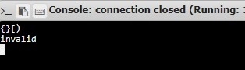

RESULT:

Hence , the Python class to find validity of a string of parentheses is printed.